TRANSISTORISED CODE LOCK WITH TORCH

This electronic lock for domestic use opens only when you connect the right combination of five switches. There are twelve switches in total. If you connect a wrong combination, the lock remains closed.At night, flip switch S3 to ‘on’ position in order to enable the torch. In the daytime, flip it back to ‘off’ position.

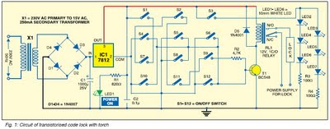

Fig. 1 shows the circuit of the transistorised code lock with torch. For easy understanding, the entire circuit can be divided in three sections: power supply, control and torch.

The power supply section is built around transformer X1, bridge rectifier comprising diodes D1 through D4 and regulator IC 7812 (IC1). The 230V AC, 50Hz AC mains is stepped down by transformer X1 to deliver a secondary output of 15V, 250 mA. The transformer output is rectified by the bridge rectifier, filtered by capacitor C1 and regulated by IC1. Capacitor C2 bypasses the ripples present in the regulated supply. When mains power is available, IC1 provides regulated 12V to the circuit and power-on LED1 glows to indicate that the circuit is enabled.

The control section is built around switches S1 through S12, transistor T1 and relay RL1. Relay driver transistor T1 is used to energise/de-energise the relay.The torch section is built around six white LEDs (LED2 through LED7) and resistors R3 and

R4.Working of the circuit is simple. To open the door, you should know the connection code. Here the connection code is switches S1, S7, S2, S11 and S9. This means you need to connect theses witches to each other by flipping them to ‘on’ position. As the connection completes, transistor T1 conducts and relay RL1 energises. As a result, thedoor lock connected between the pole and normally-open contacts of relay RL1 opens.If you connect a wrong combination, say, switches S4, S10, S11 and S6, transistor T1 does not conduct and relay RL1 remains de-energised. As a result, the door lock remains closed.

Assemble the circuit on a generalpurpose PCB and house it in a small cabinet. Fig. 2 shows the proposed cabinet arrangement for switches and LEDs. Install the cabinet at the front door of your house.

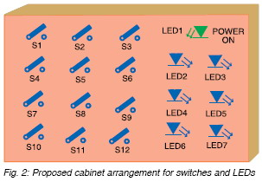

As mentioned in the beginning, switch S3 is used to enable the torch. When it is flipped to ‘on’ position, all the LEDs (LED2 through LED7) glow. Switches S4, S5, S6, S8, S10 and S12 are used just to confuse the intruders and play no role in opening the door. You can also use a 12V battery to power the circuit. In that case, remove transformer X1, diodes D1 through D4, capacitor C1 and regulator IC2 (7812) and connect the battery inside the cabinet with proper polarity.